**Weekend Adventure at Wild 3L Ranch**

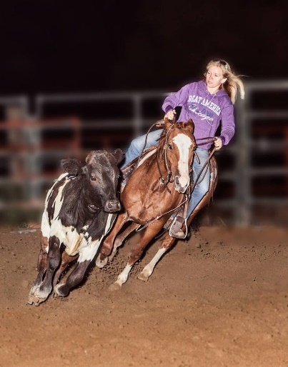

**A chance to get away from ordinary and back to nature!**

Join Wild 3L Ranch for a weekend full of adventure as we explore the Kettle Moraine State Park. For this 2 night stay, we will pack in as much riding as you can handle as we explore the beautiful horse trails within the Kettle Moraine State Park. For the weekend you will get to enjoy a sunset ride, games on horseback and a ride into town on horseback to the local pub. You will camp at the Kettle Moraine State Park with the horses and experience what a weekend is like in the beautiful setting of the Kettle Moraine. The State Park will have plenty of room for your camper, tent or RV. We will be providing snacks on Friday night and breakfast Saturday and Sunday. The cost will not include your lunch and dinner at the local pub on Saturday. The cost for the weekend is $495. If you have any questions please call Lisa at 920-251-1989. There is a limited amount of space, so book yours today! Call or send in this form with a $100 non-refundable deposit today! Deposits must be made 3 months prior to hold your spot.

**Reservation Form**

**Circle Weekend: May 1st to the 3rd, July 10th to the 12th, or September 18th to the 20th**

**Name_____________________________________________________**

**Height________________ Weight_____________________________**

**Horse Riding Experience____________________________________**

**Address___________________________________________________**

**City______________________________ State_______ Zip__________**

**Phone_______________________________ Circle: Tent, Camper or RV**

**E-Mail____________________________________________________**

**Mail your completed registration form and check to:**

Wild 3L Ranch

P.O. Box 14

Eagle, Wi 53119

lisa@wild3Lranch.com